Telecom Customer Churn Analytics
Exploratory Data Analysis of the IBM Telco Customer Churn Dataset

1. Dataset Explanation
The dataset contains account, service and billing information for 7,043 telecom customers and records whether each customer churned (left the company). The uploaded CSV has 7,043 rows and 21 columns.
Column | Meaning
customerID | Unique customer identifier
gender | Male or Female
SeniorCitizen | 1 = senior citizen; 0 = not a senior citizen
Partner, Dependents | Whether the customer has a partner / dependents (Yes or No)
tenure | Number of months the customer has stayed with the company
PhoneService, MultipleLines | Whether the customer has phone service / multiple phone lines
InternetService | Internet provider type: DSL, Fiber optic, or No
OnlineSecurity, OnlineBackup, DeviceProtection, TechSupport, StreamingTV, StreamingMovies | Whether the customer subscribes to each add-on service (Yes, No, or No internet service)
Contract | Contract type: Month-to-month, One year, or Two year
PaperlessBilling, PaymentMethod | Whether billing is paperless; how the customer pays (4 methods)
MonthlyCharges | Amount billed to the customer each month ($)
TotalCharges | Total amount billed to the customer so far ($)
Churn | Yes = customer left the company; No = customer stayed
Data preparation: TotalCharges was stored as text, and 11 blank values in it were treated as missing because a blank is not a valid charge. They were converted to numbers and filled with the column median ($1,397.47); 0 duplicate rows and repeated customer IDs were found. Two helper columns were added: a numeric churn flag (1 = churned, 0 = stayed) and NumServices (0 to 8 optional services used per customer).

2. Python Visualizations
Chart 1. Missing-value analysis
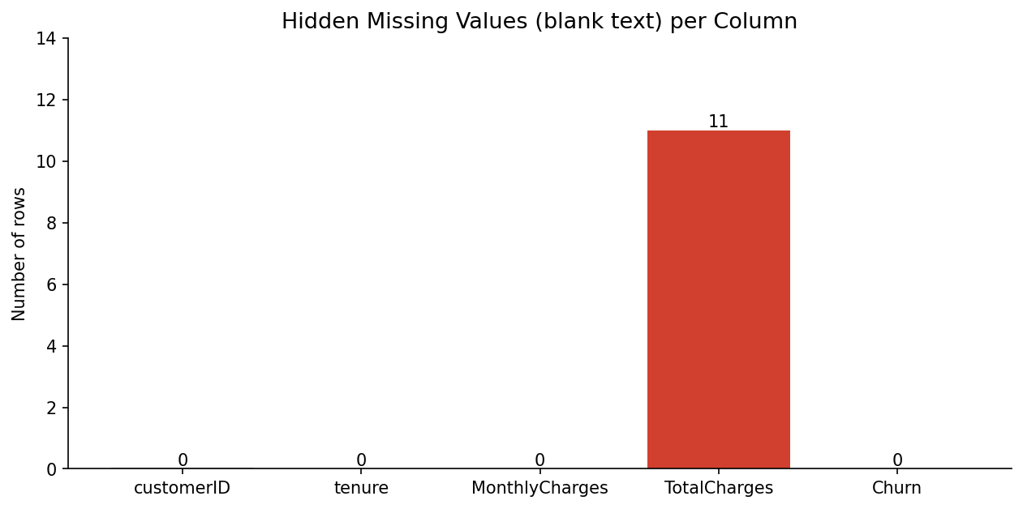
TotalCharges is the only column with hidden missing values: 11 blank entries (0.16% of rows). All 11 belong to brand-new customers with tenure 0 who had not been billed yet. They were converted to numbers and filled with the median for the cleaned dataset.
Chart 2. Tenure histogram
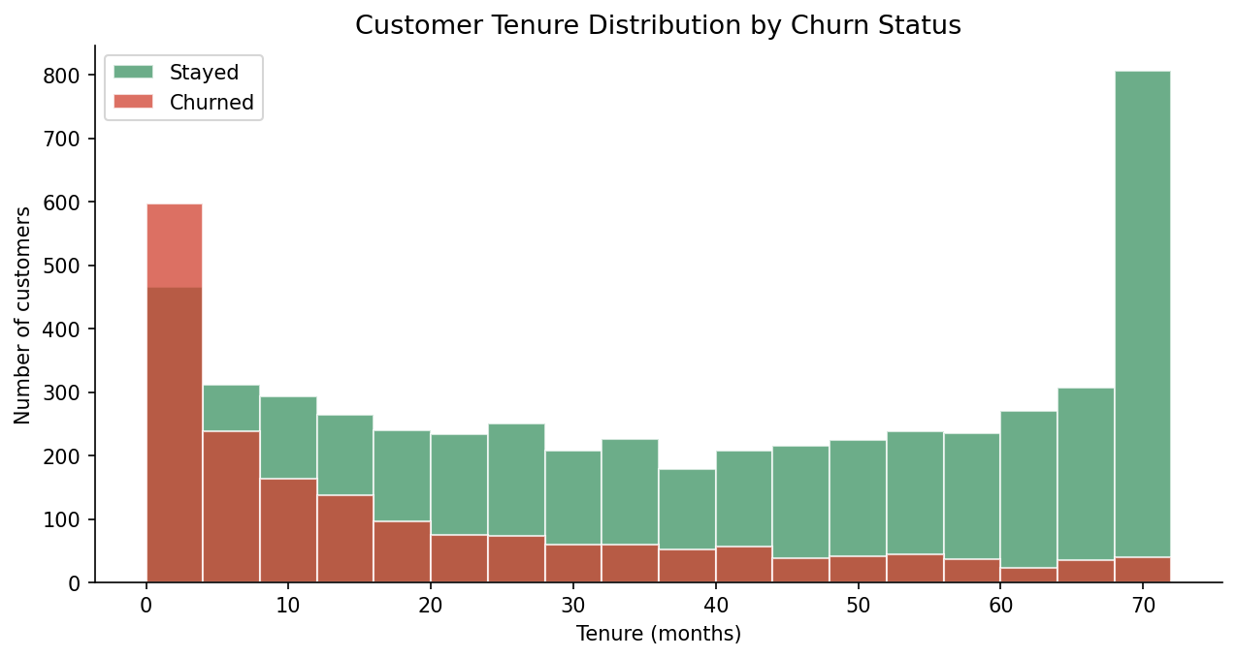
The chart compares tenure for customers who stayed and customers who churned. Churned customers are concentrated at the shortest tenures, while retained customers are spread across the whole range. The median tenure is 10 months for churned customers and 38 months for retained customers.
Chart 3. Box plots of key measurements
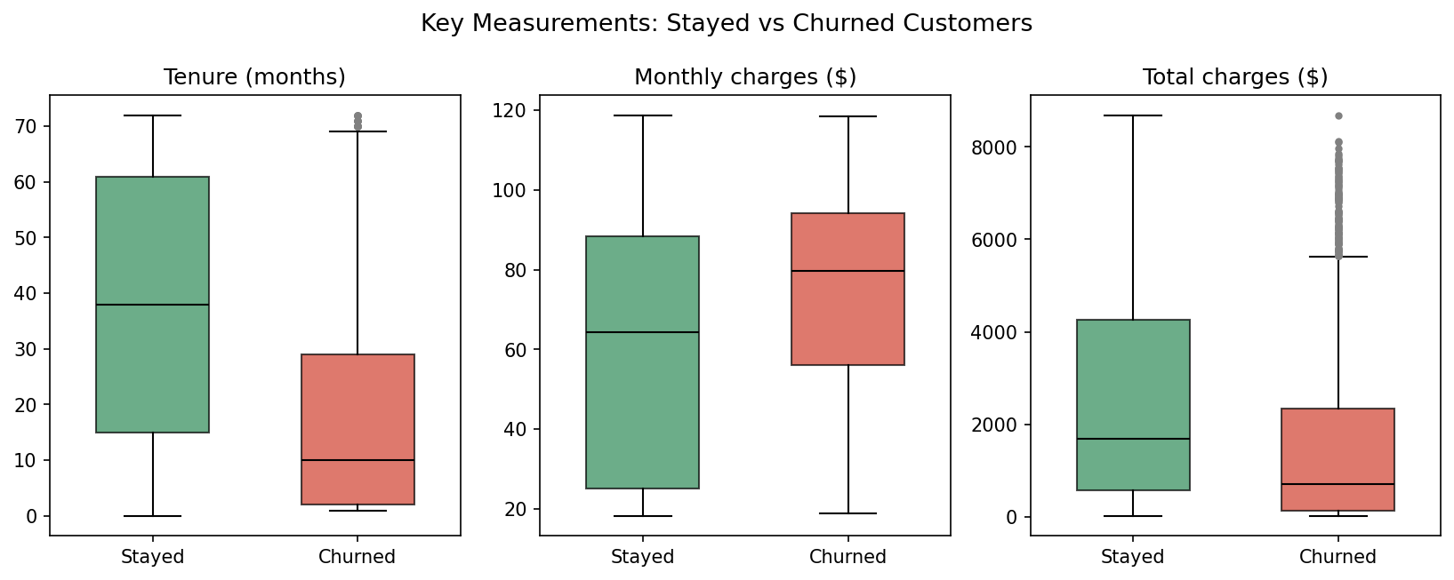
The box plots compare tenure, monthly charges and total charges for both groups. Median monthly charges are $64.4 for customers who stayed and $79.7 for customers who churned, while median total charges are lower for churned customers ($703.55 versus $1,683.60) because they stay for less time. No IQR outliers were found in these columns.
Chart 4. Churn outcome counts
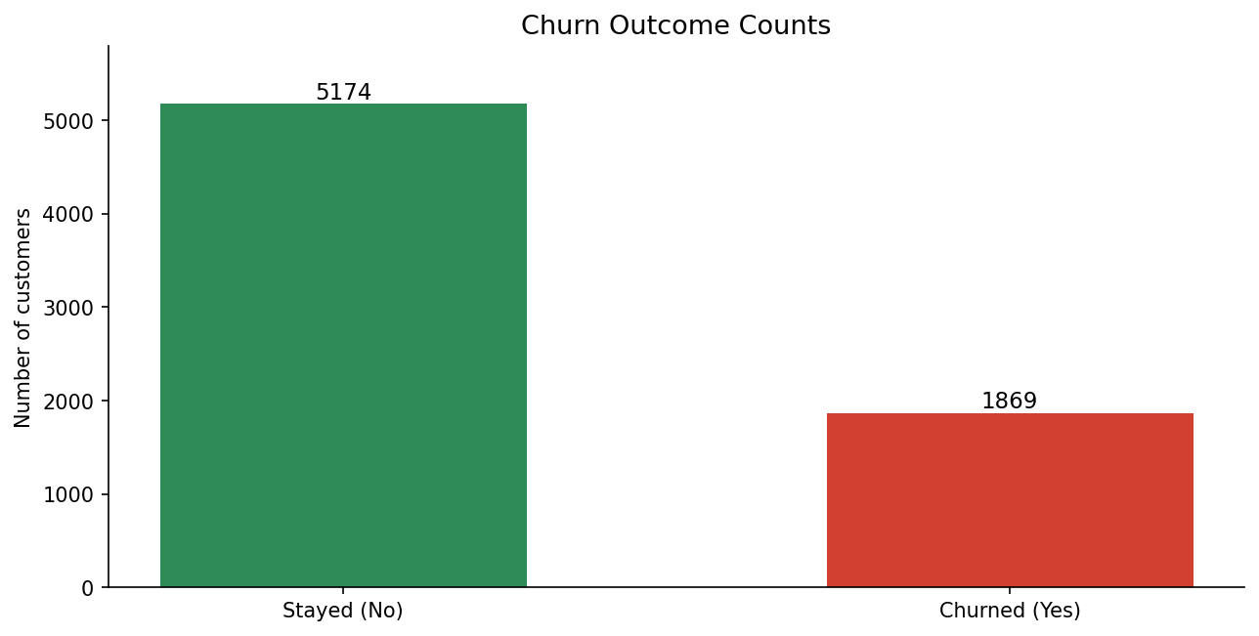
There are 5,174 customers who stayed and 1,869 who churned. This means 26.5% of the records are in the churn group, so the classes are imbalanced.
Chart 5. Correlation heatmap
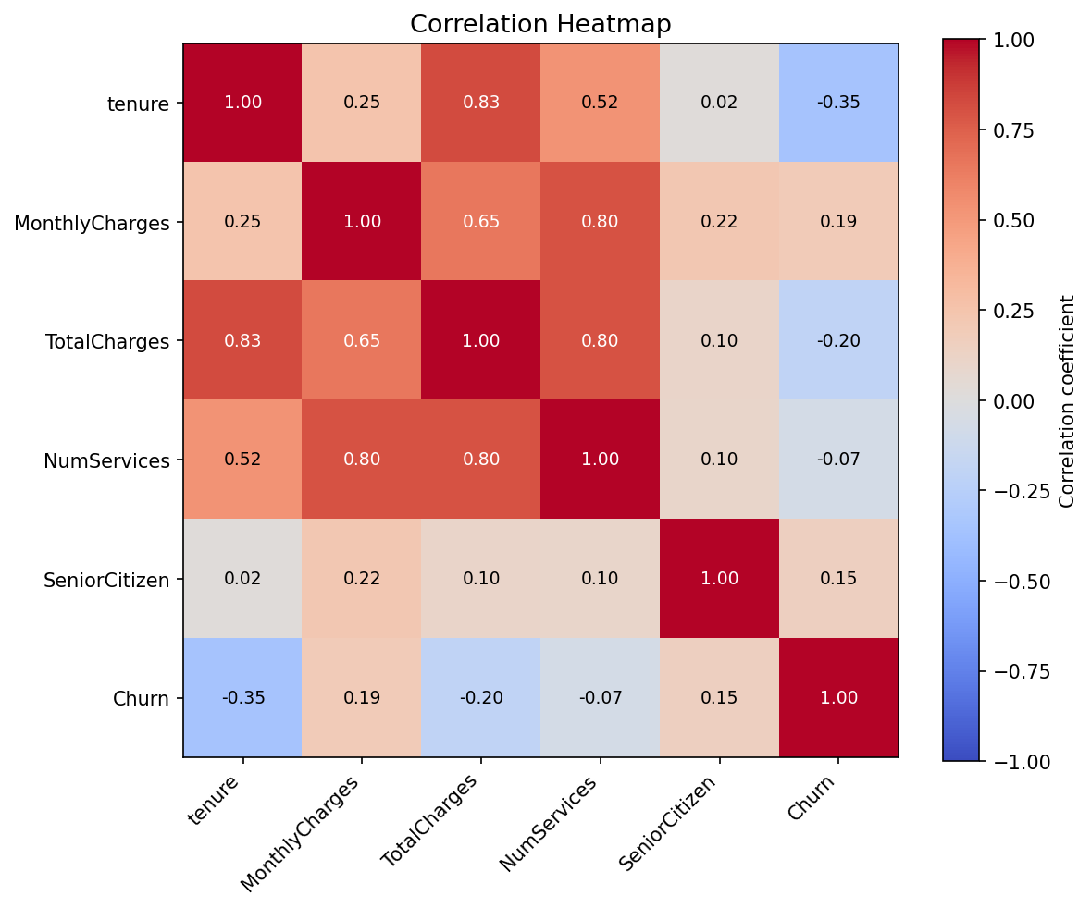
The heatmap shows how the numeric columns move together. Tenure has the strongest negative correlation with churn (r = -0.35), while MonthlyCharges has a weak positive correlation (r = 0.19). Tenure and TotalCharges are strongly related (r = 0.83); correlation does not prove that one variable causes another.
Chart 6. Monthly charges vs tenure
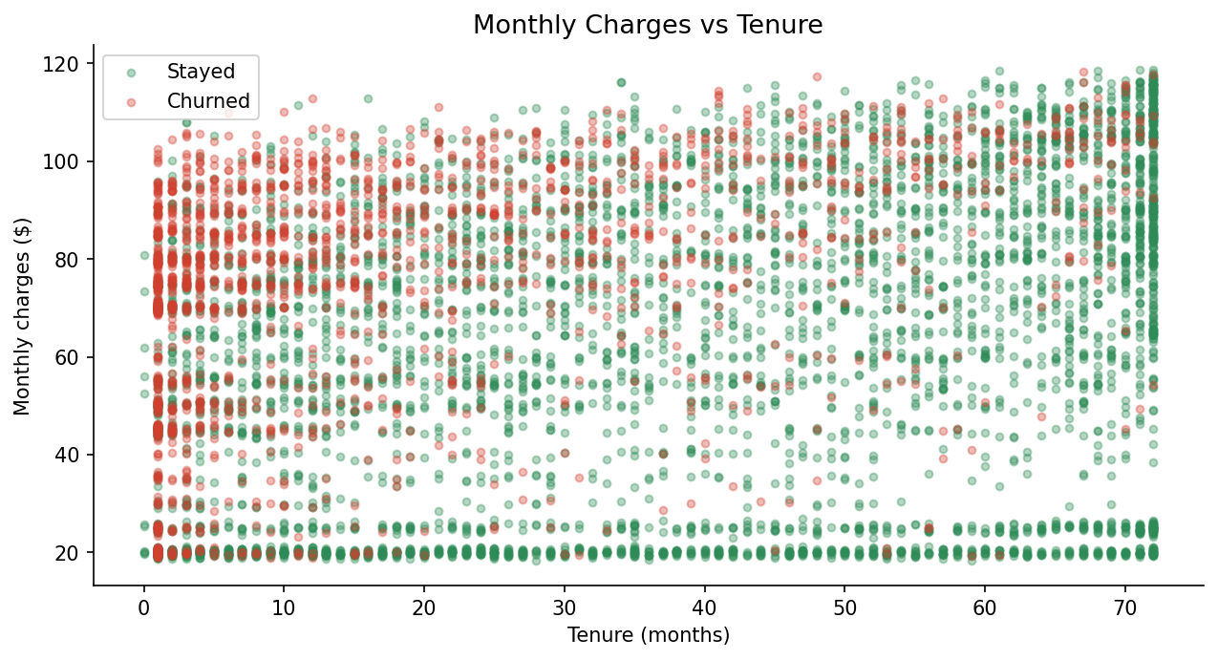
Each point represents a customer, coloured by churn outcome. Churned customers appear mostly at short tenures, and their average monthly charge is higher ($74.4 versus $61.3 for customers who stayed).
Chart 7. Churn rate by contract type
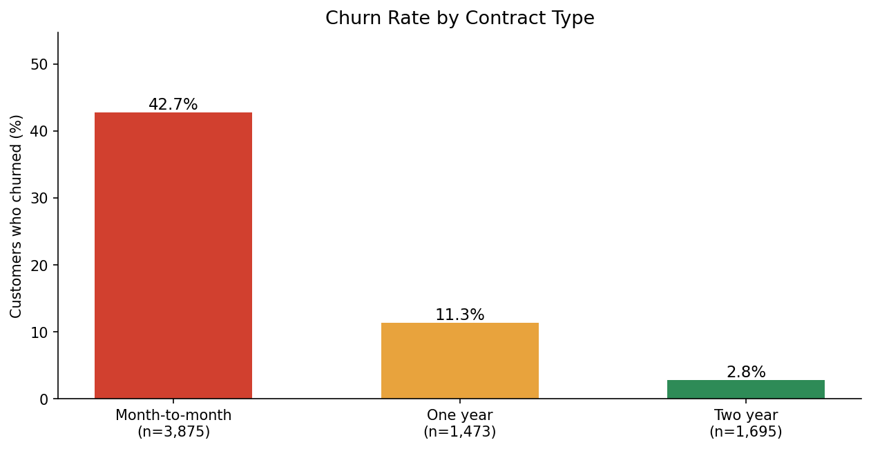
Month-to-month customers churn at 42.7%, compared with 11.3% for one-year contracts and 2.8% for two-year contracts, which makes contract type one of the clearest drivers of churn in the data.

3. Power BI Dashboard
The dashboard image uses values calculated from the uploaded CSV. The filter controls are shown as a visual mock-up; they are not interactive in this image.
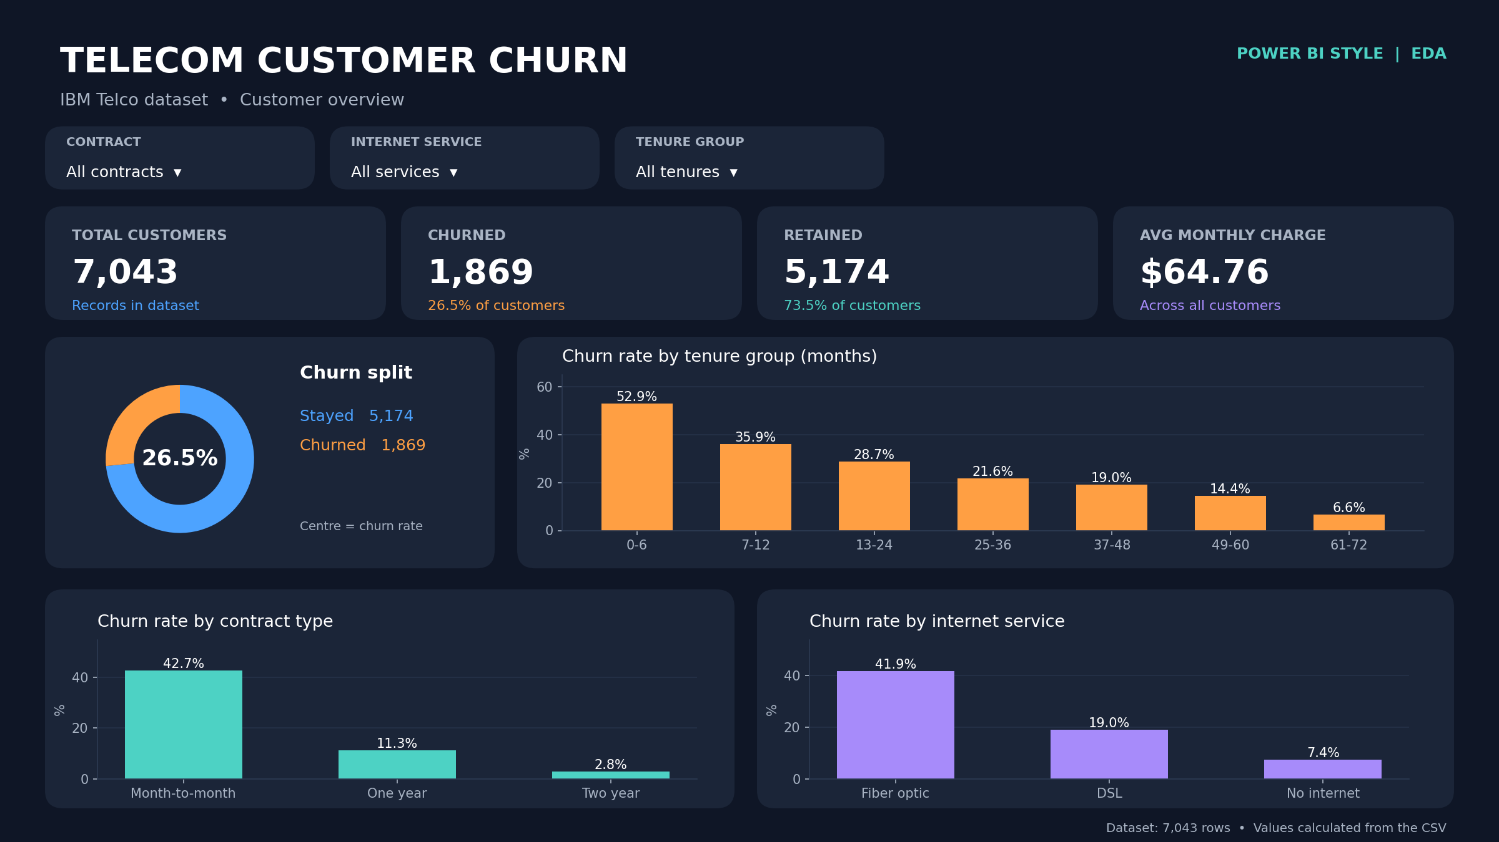

What the dashboard shows
The KPI cards show 7,043 customers, 1,869 churned customers (26.5%), 5,174 retained customers (73.5%), and an average monthly charge of $64.76.
The charts compare the churn split, churn rate by tenure group, contract type and internet service. The slicers are intended to filter by contract, internet service and tenure group; the highest churn rate by tenure group is 0-6 months at 52.9%.

4. Tableau Dashboard
This Tableau-style image presents the same dataset and verified calculations in a lighter dashboard layout. The filter controls are visual examples only and do not change the image.
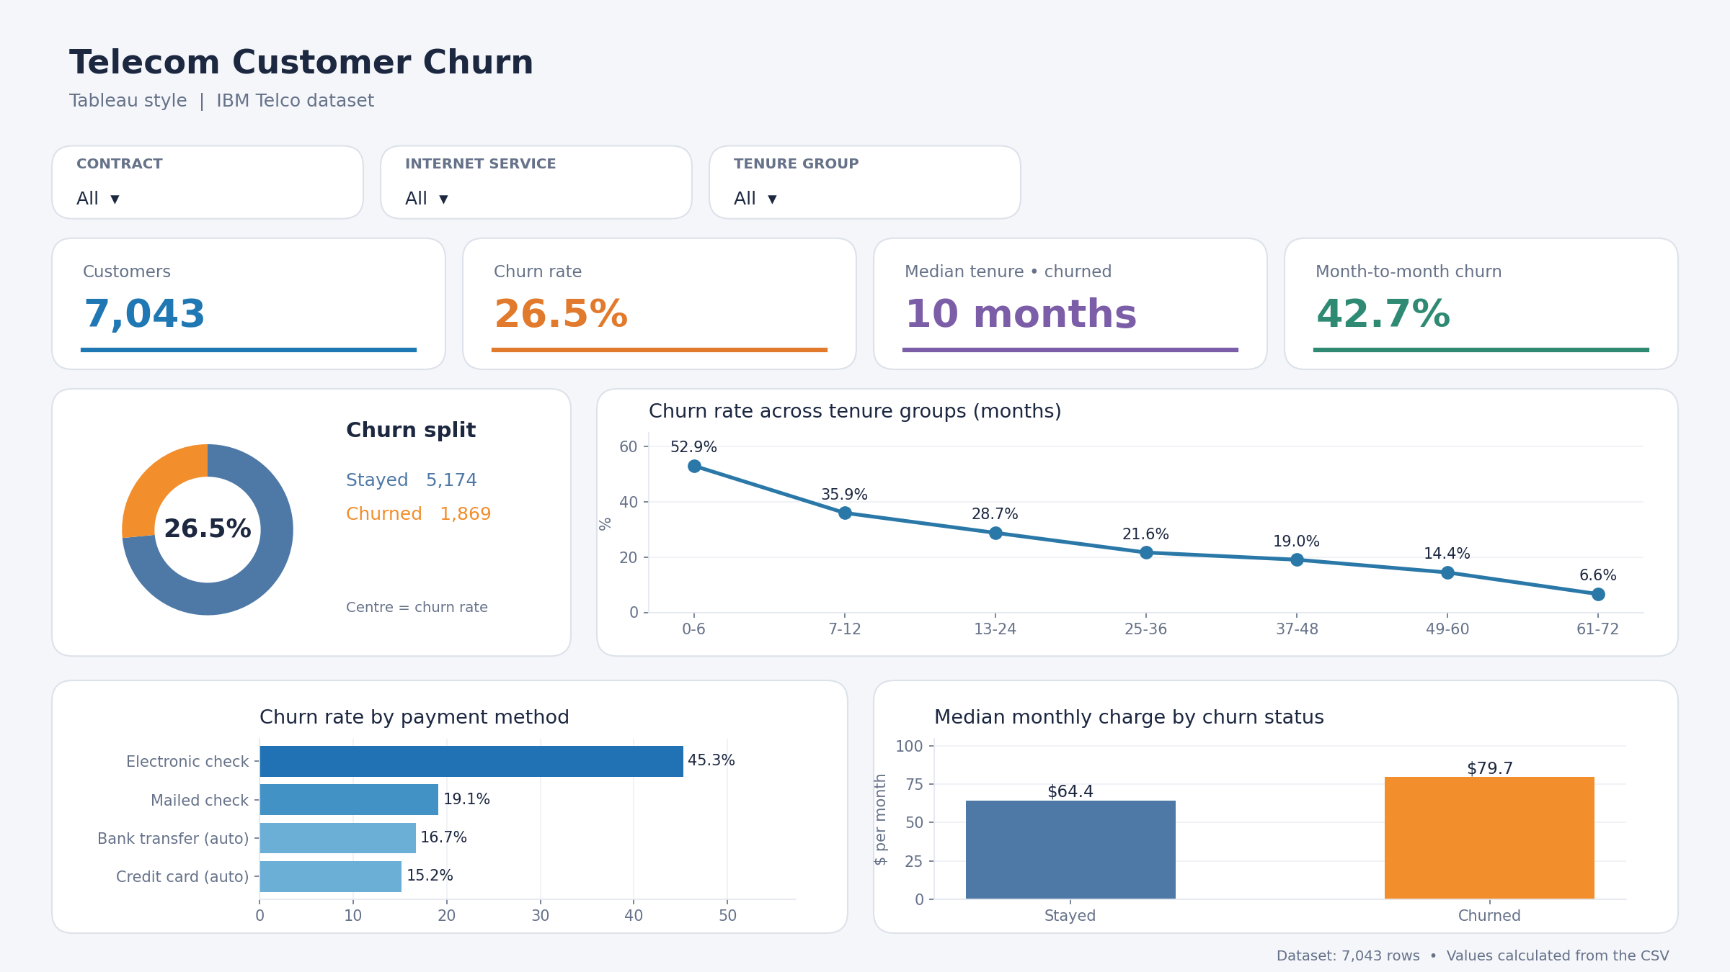

What the dashboard shows
The KPI cards show the total customer count, churn rate (26.5%), median tenure of churned customers (10 months), and the month-to-month churn rate (42.7%).
The charts show the churn split, churn rate across tenure groups, churn rate by payment method, and median monthly charge by churn status. Electronic check has the highest payment-method churn rate (45.3%), and churned customers have a higher median monthly charge ($79.7 versus $64.4).

5. Key Findings
- Customer churn is a real problem for this company: 26.5% of customers (1,869 of 7,043) left, roughly 1 in 4.
- Tenure matters most. Churned customers have a median tenure of 10 months versus 38 for retained customers, and churn falls from 52.9% in the first 6 months to 6.6% after 61 months.
- Contract type is a strong signal. Month-to-month customers churn at 42.7%, compared with 11.3% for one-year and 2.8% for two-year contracts.
- Fiber optic customers (41.9%) and electronic check payers (45.3%) churn far more than customers with DSL (19%) or automatic payment methods (15.2% to 16.7%).
- Churned customers pay more per month (median $79.7 versus $64.4). Correlation does not prove causation, and this is a single snapshot from one company, so the results may not apply to other telecom providers.

